Name: Zainab Azeem

Program: BCS

Roll No: 21P-8025

1. Write a python function that takes dictionary as a parameter your function should print all

the keys and values of the dictionary and return the sum all the items (Values) in a

Dictionary. Check if the value of sum is even your program should print “SUM IS

EVEN” otherwise it should print “SUM IS ODD”.

CODE

def function(dic): #def function for sum of dic

sum=0

for x,y in dic.items():

print(x,y) #print key and values from dic

sum+=y

if sum%2==0: #condition if sum is even

print("sum is even")

else:

print("sum is odd") #condition if sum is odd

return sum

dic={"ali":10,"laiba":50,"eman":70,"hamza":90}

function(dic) #function call

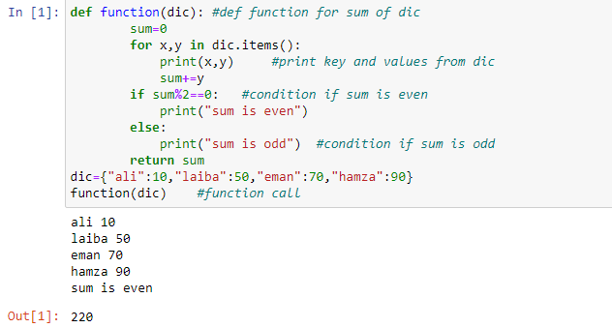

2. Write a Python program calculate the product, multiplying all the numbers of a given

tuple.

CODE

tupe=(2,4,5,6,7) #multiply all numbers in tuple

pro=1

for i in tupe: #taking loop

pro*=i

print("product of all numbers in tuple:",pro) #print product

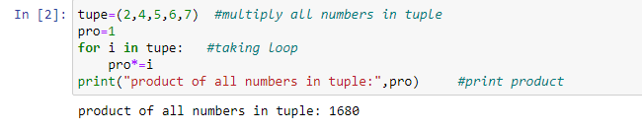

3. Write a Python function search_element(l) that take nested list as a

parameter. Your function should ask the user to input element to search

if the search element is in nested list your function should return true

or false

def search_element(l): #def function

for i in l:

for j in i:

if x==j: #condition to check no is present in list

a=True

break

else:

a=False

if a==True:

break

if a==True:

return True

else:

return False

x=int(input("enter number to search:")) #enter no to search

l=list1=[[1,2,3],[4,5,6],[7,8,9]] #nested list

search_element(l) #function call

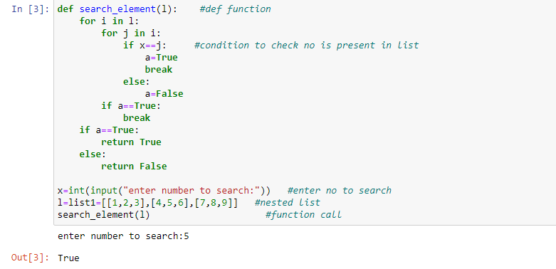

4. Build a GPA calculator that inputs grades of N number of different subjects along with

the credit hours from the user and displays the user’s GPA. The input grades and their

corresponding grading points are given below.

CODE

GRADE={"A":4.0,"A-":3.67,"B+":3.33,"B": 3.0,"B-":2.67,"C+":2.33,"C":2.0,"C-":1.67,"D+":1.33,"D":1.0,"F":0}

n=int(input("enter number of subjects:")) #enter no of subjects

GPA=0 #initilize GPA,CH=0

CH=0

count=1

for i in range(n):

X=input("enter your grade in subject"+str(count))

Y=int(input("enter your hours in subject"+str(count)))

count+=1

sum=GRADE[X]*Y #grade*credit hours

GPA+=sum

CH+=Y

gpa=GPA/CH #GPA= (GP1 * CH1 + GP2 * CH2 +......+ GPN * CHN)/ (CH1 + CH2 +.......+ CHN)

print(round(gpa,2))

